1. Events page: image carousel gallery
2. Events page:
   1. MCC → vyshnavi to send invitation
   2. Healing Circle 2.0 →
3. Donation link : <https://buymeacoffee.com/beinglagom>
   1. Stripe: <https://www.paypal.com/ncp/payment/NA3GVN9BUTSYL>
   2. <https://buy.stripe.com/7sY4gy48I438cae37R5Rm01>
4. Articles written by various team members over the years to be integrated to the website - (also Vyshnavi’s article is red lined version)
   1. [1. Vyshnavi; Human First; 23/5/21.docx](https://docs.google.com/document/d/1TblCAmcPoAht1ytfPv8oXLL0ewlMzs7x/edit?usp=drive_link&ouid=112324895261536750033&rtpof=true&sd=true)
   2. [2. Vyshnavi; Doctors get sick too; 17/4.docx](https://docs.google.com/document/d/1thvsPc2P8OTwND9Bk8GO_ji2CvVjZ6uK/edit?usp=drive_link&ouid=112324895261536750033&rtpof=true&sd=true)
   3. [3. Sathwikaw; Wolverine of the wards; 24-5.docx](https://docs.google.com/document/d/1jk_WgJz3V-2REeY43wrfKUHcDXd_779C/edit?usp=drive_link&ouid=112324895261536750033&rtpof=true&sd=true)
   4. [7. Shehani; What is the root of happiness; 15-6.docx](https://docs.google.com/document/d/16SyBGC_lg3H88gYitP4BNS1KALeyCaHN/edit?usp=drive_link&ouid=112324895261536750033&rtpof=true&sd=true)
   5. [14. GrantHBrenner MD; Physicians Aren’t Immune to Suicide and Depression; 24-6](https://docs.google.com/document/d/1IN4TJMpzmt4yf3isPvvgna4vRO94l6WEsKvp_8pp56s/edit?usp=drive_link)
   6. [22. Shenara; Goodbye Again; 27/6/21](https://docs.google.com/document/d/1RXDvZIPOZJKMMpAk6SF7_7pD9szZootnJMUrwuBwHc0/edit?usp=drive_link)
   7. [25. Sathwikaw; Empty beds and Musing Heads; 1/7/21](https://docs.google.com/document/d/1muAIrAcOJTzpV9oc-uPuxbVFWLz5HniekBOYvpwd45I/edit?usp=drive_link)
   8. [4. Vyshnavi; The only way to heal it is to feel it; 23/5.docx](https://docs.google.com/document/d/1q-g7ZPk8InnTwsKcj9PKMbd7i7J7uTGR/edit?usp=drive_link&ouid=112324895261536750033&rtpof=true&sd=true)
   9. [32. Aqib; Night comes; 20-7-21](https://docs.google.com/document/d/1SGoabmMu6IBy-DVsQM_CbrEQK8iUlm7FVIvcw3eDc_Q/edit?usp=drive_link)
   10. [61. Vyshnavi; Atomic Habits- Book Synopsis; 6/12/21](https://docs.google.com/document/d/160xA7H51oyOtf3GCmUoWq5Uf4HNwMK9J-innC-B_rfs/edit?usp=drive_link)
5. Home page - to add space in between



1. Apart from IG, none of the other links work



1. Partner with us page - do we need to update the email and number? Also, towards the very bottom of the page there is a reference to “[support@being.lagom](mailto:support@being.lagom)” which should be updated? Another one terms of service - [admin@beinglagom.com](mailto:admin@beinglagom.com)

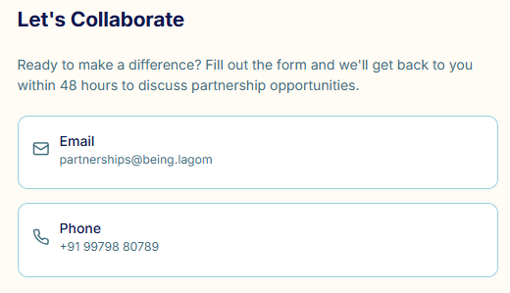

1. Lagom Lab > Love shower > to add the functionality where people could drop in their messages and those messages shower
2. Crisis support page
   1. Peer to peer network link needs slight updating - refers to BJMC
   2. Links below don’t work

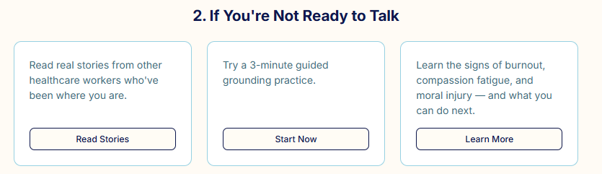

1. Merch page - we should add a narrative around where are the proceeds from the sale of merchandise going to be utilised - example below

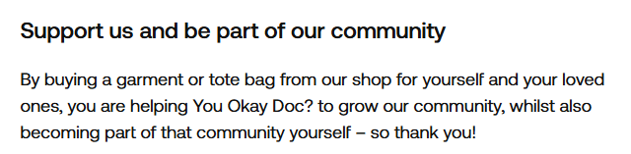

1. Merch - given that we got the design of the pen + diary etc made from TSH (didn’t end up ordering for AHM) - should we include that as well?
2. Team section - could the individual profiles of the team members on our page be linked to the LinkedIn profiles if someone were to click on the thumbnail?
3. Team section - “why lagom” - coming soon - are we going to link this to the IG posts?
4. Lagom gallery - should we also showcase the “key” IG posts that had a good reach - e.g. lorna breen plus ground ops post?
5. I was on the happyminds website and looked at their “my services” - was just thinking with ours - there is self help resources, P2P network, triage form etc - should we be having something “specific”?
6. Also, do we want to include happy minds in our partnerships?